Software Design Specification

**Final Project**

**Self Driving Car**

**Product: Final Project**

**Description: Self-driving RC Car Project**

**Status: Work in progress**

**Development Status: design and development phase**

**Product**

* Current Version :
* Current Status: Work in Progress
* Date: 11-01-2021

**Team Project**

* **Dor Getter**
* **Oren Lacker**
* **Eldar Takach**

# 1. Introduction

## 1.1 Purpose of this document

The purpose of this document is to provide a detailed description of the implementation of the project.

The goal of this project is to make an autonomous self-driving car, capable of   
Automatic lane centering(ALC), forward collision warning(FCW), lane departure warning(LDW), adaptive cruise control(ACC), avoiding obstacles, and following traffic signals and road signs.  
  
The tools used in this project and described in this document are:

* TensorFlow library for machine learning.
* OpenCV library.
* YOLO object detection.

The hardware used in this project and described in this document are:

* RC Car serving as the actual self-driving car
* An Arduino device which will drive the car.
* A Raspberry Pi 4 SOC which will be used for:
  + Collecting camera frames.
  + Navigating.
  + Compass information.
  + Running AI models.
  + Running Computer vision algorithms.

## 1.2 Scope of the development project

Road safety has been an issue for as long as cars have been in existence.

Approximately 1.35 million people die in car accidents each year, on average 3,700 people lose their lives every day on the roads. An additional 20-50 million suffer non-fatal injuries, often resulting in long-term disabilities. More than half of all road traffic deaths occur among vulnerable road users—pedestrians, cyclists, and motorcyclists. Road traffic injuries are the leading cause of death among young people aged 5-29. Young adults aged 15-44 account for more than half of all road deaths. More than 90% of all road fatalities occur in low- and middle-income countries, even though these countries have approximately 60% of the world’s vehicles. On average, car accidents cost countries 3% of their gross domestic product. Car accidents are the single greatest annual cause of death of healthy U.S. citizens traveling abroad.

Recent developments in machine learning and artificial intelligence along with the ever-increasing performance of modern-day computers have enabled the use of these technologies in developing self-driving cars. These cars have several advantages, as described below:

* Better road safety: Machines are not prone to human error and distractions, leading to swift and appropriate responses in real-time road conditions.
* Reduced commute time: With cars communicating with each other and using modern GPS systems, commute times can be greatly reduced as self-driving cars reduce the *"phantom effect"* in modern-day traffic.
* Increased productivity: Reduced commute times means more time can be spent on what matters more.
* Reduced expenditure: A reduction in accidents will directly lead to reduced expenditure on damages.
* Environment-friendly: Efficient driving styles of the self-driving car will lead to lower emissions.
* A solution to the parking problem: Most of the modern cities face parking problems which can be resolved by this solution.
* Better traffic discipline: reduced need of law enforcement.
* Potential for a new design: Because a vehicle may eventually function as a self-guided train car, the potential for new car designs is huge. With no need for complicated driving tools, self-driving cars could include new ways to relax or to stay entertained

## 1.4 Overview of document

This document is divided into several sections (see Table of Contents) with intended readers being developers and software managers. Sections have, however, been written in a manner that can be understood by anyone having basic knowledge about the software.

This Software Design Specification also includes:

* System architecture description
* A detailed description of components
* Reuse and relationships with other products
* Design decisions and tradeoffs

The design has been made clear using class diagrams and sequence diagrams.

# 

# 

# 

# 2. Conceptual Architecture

**2.1 Overview of modules and components**

1. Raspberry Pi 4
   * **Camera:** The camera module is responsible for capturing what is right in front of the car. This camera data is processed by the machine learning algorithm to judge the car's environment.
   * **GPS:** The GPS module is used to capture the car's current location and help it navigate through the location points to its destination.
   * **Compass:** The compass module provides the car's current heading direction and helps correct the car's direction of motion.
   * **Machine Learning Algorithm:** The machine learning algorithm is at the heart of this project. The model processes visual data from the Android device to judge the car's environment and control the car's motion.
2. Arduino
   * **GPIO Driver:** This software driver is responsible for parallel communication with the Pi. It is used for receiving speed and turn data from the Pi, and for running the motors at the desired speed and direction.
   * **Motor Driver:** This software driver is responsible for running the car's motors at the desired speed and direction. It also controls the car's degree and direction of the turn.
3. Car
   * **DC Motor:** These motors are responsible for actually running the car.

**2.2 Structure and relationships**

The structure and hierarchy of the system can be understood from the following structural diagram.

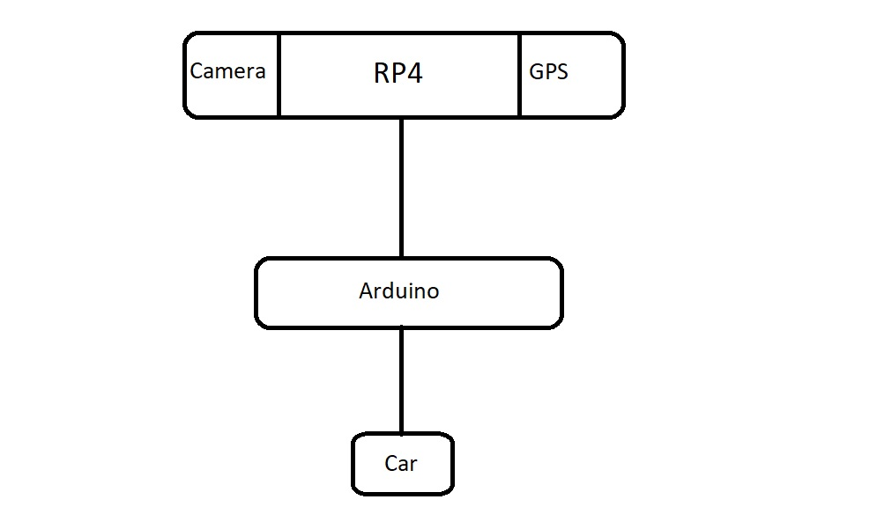

# 3. Logical Architecture

### 3.1 Sequence Diagram

### 

## 